

Name: Dineshvaran A/L Mayilvaganam

Login ID: dineshvaran@oasis-portal.com

Course title: Accounting Fundamentals

Subject Code: BHM03

Submitted date: 07 August 2017

**Table of Contents**

|  |  |  |
| --- | --- | --- |
| **No** | **Details** | **Page** |
| 1 | Executive Summary | 2 |
| 2 | Introduction | 3 |
| 3 | Assignment Question | 4 - 12 |
|  | Question 1 | 4 - 6 |
|  | Question 2 | 7 - 9 |
|  | Question 3 | 10 - 11 |
|  | Question 4 | 12 - 13 |
| 4 | Conclusion | 14 |
| 5 | References | 15 |
|  | Appendix | 16 - 17 |

**Executive Summary**

The purpose of this assignment is to be able to understand accounting fundamental. Accounting can seem like a daunting discipline for a small business owner. When you discuss accounting, you'll hear a lot of complex terms. It helps to begin with fundamental accounting. All advanced accounting depends on the fundamental equation that defines every business's success or failure. From that we can learn the ins and outs of fundamental accounting so you can get a handle on the primary financial functions of your small business. First of all, I will introduce four parts which entitled in this task. In first part, I will explain about the role of accounting. Furthermore, in second part I will explain about the difference between accounts payable and accounts receivable. In third part, I will describe the company's profit appear as a credit on its balance sheet with the reasons. Finally, in fourth part I will briefly explain about reconciling an account. From every part, we can learn about the importance and the roles of accounting fundamental.

**Introduction**

Business is an economic activity undertaken with the motive of earning profits and to maximize the wealth for the owners. Business cannot run in isolation. Largely, the business activity is carried out by people coming together with a purpose to serve a common cause. This team is often referred to as an organization, which could be in different forms such as sole proprietorship, partnership, body corporate etc. The rules of business are based on general principles of trade, social values, and statutory framework encompassing national or international boundaries. While these variables could be different for different businesses, different countries etc., the basic purpose is to add value to a product or service to satisfy customer demand. The business activities require resources (which are limited & have multiple uses) primarily in terms of material, labour, machineries, factories and other services. The success of business depends on how efficiently and effectively these resources are managed. Therefore, there is a need to ensure the businessman tracks the use of these resources. The resources are not free and thus one must be careful to keep an eye on cost of acquiring them as well. As the basic purpose of business is to make profit, one must keep an ongoing track of the activities undertaken in course of business.

The best way to find them is to record all the business activities. Recording of business activities has to be done in a scientific manner so that they reveal correct outcome. The science of book-keeping and accounting provides an effective solution. It is a branch of social science. This study material aims at giving a platform to the students to understand basic principles and concepts, which can be applied to accurately measure performance of business. After verifying the various questions in this task, students able to verify differences between accounts payable and accounts receivable, role of accounting, how important the company's profit appear as a credit on its balance sheet and the meant of reconciling an account. Accounting is the systematic and comprehensive recording of financial transactions pertaining to a business, and it also refers to the process of summarizing, analyzing and reporting these transactions to oversight agencies and tax collection entities. Fundamental means core component or fact upon which other aspects are built. A fundamental fact is a fact that is vital, and must be known before secondary assumptions or conclusions can be drawn. Accounting fundamental is all about advanced accounting depends on the fundamental equation that defines every business's success or failure. To understand about accounting fundamental, we must know the role play of accounting which be the main knowledge to build a good and effective business. The way we understand the type of account it can helps us to identify the category of payment which be the part of business. In the rest of this task, we can learn how to prepare a set of financial statements and how to interpret them.

**Assignment Questions**

**Question 1**

**In a brief but comprehensive response, define the role of accounting.**

Accounting is often called “the language of business.” Why? Because it *communicates* so much of the information that owners, managers, and investors need to evaluate a company’s financial performance. These people are all stakeholders in the business. Therefore, they’re interested in its activities because they’re affected by them. In fact, the purpose of accounting is to help stakeholders make better business decisions by providing them with financial information. Obviously, you wouldn’t try to run an organization or make investment decisions without accurate and timely financial information, and it’s the accountant who prepares this information. More importantly, accountants make sure that stakeholders understand the *meaning* of financial information, and they work with both individuals and organizations to help them use financial information to deal with business problems. Actually, collecting all the numbers is the easy part—today, all you have to do is start up your accounting software. The hard part is analysing, interpreting, and communicating the information. Of course, you also have to present everything clearly while effectively interacting with people from every business discipline. In any case, we’re now ready to define accounting as the process of measuring and summarizing business activities, interpreting financial information, and communicating the results to management and other decision makers.

**Fields of Accounting**

Accountants typically work in one of two major fields. *Management accountants* provide information and analysis to decision makers *inside* the organization in order to help them run it. *Financial accountants* furnish information to individuals and groups *both inside and outside* the organization in order to help them assess its financial performance.

In other words, management accounting helps you keep your business running while financial accounting tells you how well you’re running it.

**Management Accounting**

Management accounting plays a key role in helping managers carry out their responsibilities. Because the information that it provides is intended for use by people who perform a wide variety of jobs, the format for reporting information is flexible. Reports are tailored to the needs of individual managers, and the purpose of such reports is to supply *relevant, accurate, timely information* in a format that will aid managers in making decisions. In preparing, analyzing, and communicating such information, accountants work with individuals from all the *functional areas* of the organization such as human resources, operations, marketing, and finance.

**Financial Accounting**

Financial accounting is responsible for preparing the organization’s financial statements which including the *income statement*, the *statement of owner’s equity*, the *balance sheet*, and the *statement of cash flows*. That summarize a company’s past performance and evaluate its current financial condition. In preparing financial statements, financial accountants adhere to a uniform set of rules called Generally Accepted Accounting Principles (GAAP). The basic principles for financial reporting issued by an independent agency called the Financial Accounting Standards Board (FASB). Users want to be sure that financial statements have been prepared according to GAAP because they want to be sure that the information reported in them is accurate. They also know that they can compare the statements issued by one company to those of another company in the same industry.

While companies headquartered in the United States follow U.S.-based GAAP, many companies located outside the United States follow a different set of accounting principles called International Financial Reporting Standards (IFRS). These multinational standards, which are issued by the International Accounting Standards Board (IASB), differ from U.S. GAAP in a number of important ways. IFRS, for example, is a little stricter about the ways you can calculate the costs of inventory, but we’re not going to dwell unnecessarily on such fine distinctions. Bear in mind, however, that, according to most experts, a single set of worldwide standards will eventually emerge to govern the accounting practices of both U.S. and non-U.S. companies.

**Who Uses Financial Accounting Information?**

The users of managerial accounting information are pretty easy to identify basically, they’re a firm’s managers. We need to look a little more closely, however, at the users of financial accounting information, and we also need to know a little more about what they do with the information that accountants provide them.

**Owners and Managers**

In summarizing the outcomes of a company’s financial activities over a specified period of time, financial statements are, in effect, report cards for owners and managers. They show, for example, whether the company did or didn’t make a profit and furnish other information about the firm’s financial condition. They also provide information that managers and owners can use in order to take corrective action.

**Investors and Creditors**

If you loaned money to a friend to start a business, wouldn’t you want to know how the business was doing? Investors and creditors furnish the money that a company needs to operate, and not surprisingly, they feel the same way. Because they know that it’s impossible to make smart investment and loan decisions without accurate reports on an organization’s financial health, they study financial statements to assess a company’s performance and to make decisions about continued investment.

**Government Agencies**

Businesses are required to furnish financial information to a number of government agencies. Publicly owned companies, for example the ones whose shares are traded on a stock exchange, it must provide annual financial reports to the Securities and Exchange Commission (SEC), a federal agency that regulates stock trades. Companies must also provide financial information to local, state, and federal taxing agencies, including the Internal Revenue Service.

**Other Users**

A number of other external users have an interest in a company’s financial statements. Suppliers, for example, need to know if the company to which they sell their goods is having trouble paying its bills or may even be at risk of going under. Employees and labour unions are interested because salaries and other forms of compensation are dependent on an employer’s performance.

As a summarizes, we can see the differences between the users of management and financial accounting and the types of information issued by accountants in the two areas which shown in figure 1.0.

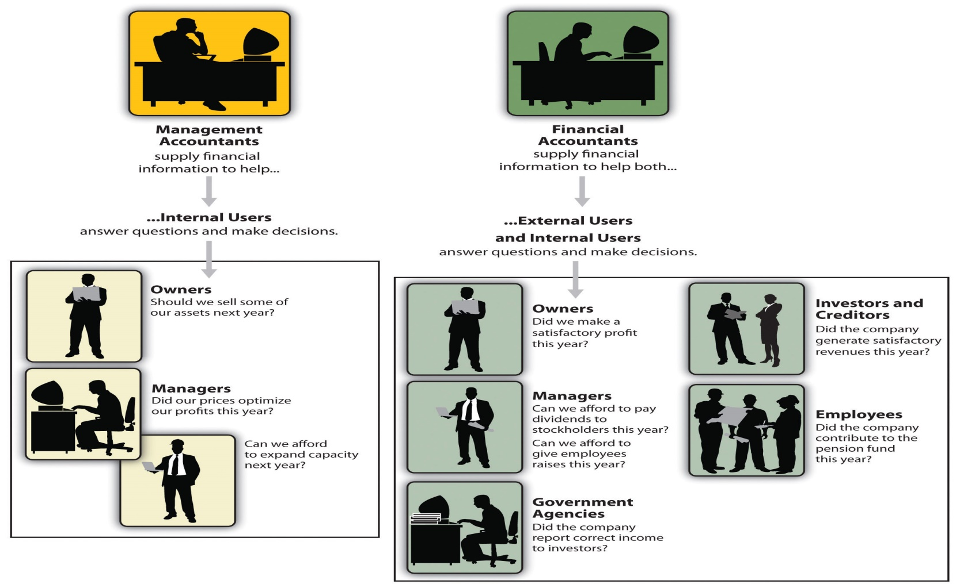

Figure1.0: Management and Financial Accounting

**Question 2**

**What is the difference between accounts payable and accounts receivable?**

The two major elements of working capital of a company are current assets and current liabilities. The assets which are readily converted into cash are considered as Current Assets while Current liabilities are those debts which fall due for payment within a short duration. Account receivable is a current asset account, which represents the money to be received by the company, against the goods delivered or services rendered to the customers. On the other hand, accounts payable is a current liability account, indicating the money owed by the company to the suppliers, and appears as a liability in the company’s Balance Sheet. Many accounting students get confused amidst these two terms, but there is a fine line of difference between account receivable and account payable.

Accounts payable are amounts a company owes because it purchased goods or services on credit from a supplier or vendor. Accounts receivable are amounts a company has a right to collect because it sold goods or services on credit to a customer. Accounts payable are liabilities. Accounts receivable are assets. Let's assume that Company A sells merchandise to Company B on credit. (Perhaps the invoice states that the amount is due in 30 days.) Company A will record a sale and will also record an account receivable. Company B will record the purchase (perhaps as inventory) and will also record an account payable. Our example reminds me of an old saying, "There are two sides to every transaction." In accounting we also expect symmetry: Company A has a sale and a receivable, Company B has a purchase and a payable.

**Definition of Accounts Receivable**

Accounts Receivable refers to the amount to be received by the entity in the future specified date for selling goods to the customers on credit. It reflects the money owed by the customers towards the company. It appears on the assets side of the Balance Sheet, under the head current assets. Bills Receivables and Debtors constitute the Account Receivables.

Every company sells goods on credit to other entities, to have better customer relations, holding an advantageous position in the market and increasing turnover as well. Although all the debtors do not prove to be good, default in payment is also made by some debtors which lead to Bad Debts. Due to this reason, a provision is always created by the company to cope up with the bad debts. The provision is known as Provision for Doubtful Debts. Few points are considered before allowing goods on credit to any customer. They are:

* **Credit Policy**: This includes decisions regarding credit period, discount rate, early payment, etc.
* **Credit Analysis**: This includes decisions regarding whether a particular customer is allowed extended credit period or not. The techniques used in this regard are the evaluation of credit ratings, past credit history, etc.
* **Collection Policy**: The Timely collection of receivables enables the reduced risk of losses.
* **Control on Receivables**: This includes follow-up of debtors and faster collection of debts.

**Definition of Accounts Payable**

A short-term obligation, need to be discharged in the future, arising out of the purchase of goods or services received or expenses made is known as Accounts Payable. It includes trade payable i.e. bills payable and creditors, and expenses payable like an advertisement expense, electricity expense or expenses on supplies, etc. It represents the money owed by the company towards suppliers and creditors. Accounts Payable appears on the liabilities side of the Balance Sheet, under the head current liabilities.

It is quite natural that the entities on credit buy goods. They are one of the major sources of finance for the company which arises very often, in the normal course of business. It is the duty of the company to pay the creditors in time because slow payment of debts will hamper the whole supply cycle, which in turn spoil the working capital cycle of the company. This will also have an ill effect on the reputation of the company.

This should be kept in mind that the company should effectively utilize the credit period, allowed by the creditors. Moreover, they must use bills of exchange to pay the debt in place of cheques.

**The difference between accounts payable and accounts receivable**

|  |  |  |
| --- | --- | --- |
| **Aspects** | **Accounts Payable** | **Accounts Receivable** |
| Meaning | Money expected to be received by the company in the future for the goods sold and services rendered to the customers on credit. | Money expected to be by the company in the future for the goods bought and services received from the suppliers on credit. |
| Represents | Money to be collected | A debt to be discharged |
| Concept | Accounts payable are amounts a company owes because it purchased goods or services on credit from a supplier or vendor. | Accounts receivable are amounts a company has a right to collect because it sold goods or services on credit to a customer. |
| Status | Liability (payable always a liability) | Asset (receivable always an asset) |
| How each affects a business | Accounts payable will decrease a company's cash | Accounts receivable will increase a company's cash |
| What causes this Transaction | Purchasing goods on credit | Selling goods on credit |

Figure 1.1: Difference between accounts payable and accounts receivable

There are many differences between accounts payable and accounts receivable. First aspect that can differentiate accounts payable and accounts receivable is about meaning. Meaning of account payable is money expected to be received by the company in the future for the goods sold and services rendered to the customers on credit. Meaning of account receivable is money expected to be by the company in the future for the goods bought and services received from the suppliers on credit.

On the other hand, represent is one of the aspects that can also differentiate accounts payable and accounts receivable. Represent for accounts payable is money to be collected while represent for accounts receivable is a debt to be discharged.

Accounts payable are amounts a company owes because it purchased goods or services on credit from a supplier or vendor while Accounts receivable are amounts a company has a right to collect because it sold goods or services on credit to a customer. This concept can give a clear picture about accounts payable and accounts receivable.

On the other side, accounts payable recorded as liability (payable always a liability) while accounts receivable is recorded as asset (receivable always an asset). In addition business affection is one of the aspect that can differentiates both accounts. Accounts payable will decrease a company's cash but accounts receivable will increase a company's cash. Besides that, accounts payable is about purchasing good on credit but accounts receivable is about selling goods on credits. Those are the clear differences of accounts payable and accounts receivable.

There are other differences between account payable and account receivable which no located in table. Accounts Receivables shows the cash expected to be received in the future, for the sales made on the credit basis. Accounts Payable is the cash to be paid within a short period, to the creditors for the sale of goods and services. Accounts Receivable is shown under the head current assets while accounts payable appears under the head current liabilities in the balance sheet. Accounts Receivable represents an amount owned by the company whereas accounts payable represents the amount owed by the entity.

Accounts Receivable reflects the amount to be collected at a future specified date, but accounts payable discloses the debt to be paid at a later date. Accounts Receivable increases cash, but it is just opposite in accounts payable. Accounts Receivable is the result of credit sales. In contrast to, accounts payable which is the outcome of credit purchases.The two primary components of accounts receivable are bills receivable and debtors. On the other hand, bills payable and creditors are the essential elements of accounts payable.

**Question 3**

**Why does a company's profit appear as a credit on its balance sheet?**

**The Balance Sheet**

The three principal financial statements are the balance sheet, the income statement which often called the profit and loss statement and the cash flow statement. The balance sheet shows your company's assets, its liabilities, and the owners' equity, which is sometimes called a company's net worth. Owners' equity is what remains after the liabilities are subtracted from the assets. The statement is called a balance sheet because the assets are always equal to the liabilities plus the owners' equity which be the equation balances. The balance sheet shows the financial condition of your company at a single point in time. The balance sheet is also not the financial statement that shows company profit.

**Profits vs. Profitability**

Because assets must be equal to liabilities plus owners' equity, if liabilities are greater than assets, the owners' equity will be negative. A negative owners' equity obviously reflects that the company was in red ink, or was not "profitable" as of the specified date on the balance sheet, but there is a difference between "profits" and "profitability." The balance sheet does not show profit, which is simply the difference between revenue and expenses. You can get a clue as to a company's profitability from the balance sheet by looking at the owners' equity, especially if the owners' equity is a negative figure. Profitability is frequently defined as a measurement of a company's performance, where performance can be either over a period of time or "as of" a specified date.

**Profit and Loss Statement**

The profit and loss statement, as its name indicates, is the only financial statement that reliably shows a company's profit. The profit and loss statement covers a period of time, but does not usually extend beyond one year. It shows how much revenue the company generated from sales and the company's expenses during that period. The residual after all expenses are accounted for and subtracted from revenue is the profit. Expenses usually include cost of goods sold, sales returns and allowances, and operating expenses.

**Cash Flow Statement**

The cash flow statement shows the sources and uses of cash that flow into and out of a company over a period of time. Business owners find this statement to be very useful in gauging the availability of cash from internal sources, and the need to use external sources for cash to meet known financial obligations, such as repayment of debt.

**Why Does A Company's Profit Appear As A Credit On Its Balance Sheet?**

For a given date, the Balance sheet shows the firm's:

* Total Assets - Items of value the firm owns or controls, which it uses to earn revenues.
* Total Liabilities -What the firm owes.
* Total Owners Equities - What the firm owns outright.

More accurately, the balance sheet shows end-of-period balances in the firm's Assets, Liabilities, and Owners Equity accounts. However, its name includes "Balance" for another reason. Note especially that its 3 main sections represent the accounting equation:

**Assets = Liabilities + Owners Equity**

The term balance applies because the sum of the firm's assets must equal (balance) the sum of its liabilities and owner’s equities. This balance holds, always, whether the firm's financial position is very good, or terrible. Double entry principles in accrual accounting ensure that every change to the total on one side brings an equal, offsetting change on the other side.

The [accounting equation](https://www.accountingcoach.com/blog/accounting-equation) and the [double entry system](https://www.accountingcoach.com/blog/what-is-the-double-entry-system) provide an explanation why a company's profit appears as a credit on its balance sheet. Asset accounts usually have [debit balances](https://www.accountingcoach.com/blog/what-is-a-debit-balance) while liabilities and owner's or [stockholders' equity](https://www.accountingcoach.com/blog/what-is-stockholders-equity) usually have [credit balances](https://www.accountingcoach.com/blog/what-is-a-credit-balance). When a company provides services for cash, its asset Cash is increased by a debit and its [owner's equity](https://www.accountingcoach.com/blog/what-is-owners-equity) is increased by a credit. The credit is initially recorded in a revenue account, but revenue accounts are [temporary accounts](https://www.accountingcoach.com/blog/what-is-a-temporary-account) that cause owner's equity to increase.  
  
 If the owner withdraws some cash for personal use, the asset Cash will decrease through a credit and the owner's equity will decrease through the debit part of the accounting entry. The debit might initially be recorded in the sole proprietor's Drawing account but this [account](https://www.accountingcoach.com/blog/what-is-an-account) is also a temporary account that will cause the owner's equity to decrease.  
  
 Generally speaking, the credit balance reported in the owner's or stockholders' equity section of the balance sheet reflects the owners' investments in the company plus the profits earned minus the amounts distributed to the owners since the time that the company began.

**Question 4**

**What is meant by reconciling an account?**

**Account reconciliation**

Account reconciliation is the process of comparing transactions you have recorded for a financial account against a monthly statement from a bank, credit card or other financial institution to ensure that your account records are identical. If you're not using personal finance software, the record of your transactions would likely be in a paper register that you keep updated, like a [check register](https://www.thebalance.com/use-check-registers-315289). If you're using [personal finance software](https://www.thebalance.com/tips-for-choosing-budget-software-1293610), your transaction records are in the form of your account registers. There are two category in reconciliation account which shown as below.

**Reconciliation in Personal Accounting**

At the end of every month, many individuals reconcile their check books and credit card accounts by comparing their cancel checks, debit card receipts and credit card receipts with their bank and credit card statements. This type of account reconciliation makes it possible to determine whether money is being fraudulently withdrawn. It also ensures that financial institutions have not made any errors with individuals' accounts, and it gives individual consumers an overall picture of their spending. When an account is reconciled, the statement's transactions and ending balance should match the account holder's records. For a checking account, it is also important to know how any pending deposits or checks outstanding affect the statement balance.

**Reconciliation in Business Accounting**

Account reconciliation is also important for businesses. Businesses must reconcile their accounts to check for fraud and to prevent balance sheet errors. Businesses typically use accounting software to help them perform account reconciliations. Mistakes can have serious ramifications for publicly traded companies. For example, an auditor who reviews the company’s financial statements in accordance with federal regulations such as the Sarbanes-Oxley Act could find a material error, which the company would have to publicly disclose as a failure of controls, a material misstatement and/or a material weakness. Without accurate financial information, a company cannot make well-informed decisions.

**What is meant by reconciling an account?**

Reconciling an account often means proving or documenting that an account balance is correct. For example, we reconcile the balance in the general ledger account Cash in Checking to the balance shown on the bank statement. The objective is to report the correct amount in the general ledger account Cash in Checking. You will often need to adjust the general ledger account balance for items appearing on the bank statement that were not entered in the general ledger account.

I recall being asked to reconcile the general ledger account Freight Payable. What I needed to do was provide documentation that the balance in Freight Payable was proper. I proceeded to look at the shipments of recent sales and then determined how much we would be obligated to pay for the freight on those sales. We then adjusted the balance in Freight Payable to my documented amount. This reconciliation was done to have the correct account balance and to provide the outside auditors with documentation which could easily be reviewed.

I also reconciled the balance in Utilities Payable by computing the daily cost of each utility that the company used. The cost per day was then multiplied by the number of days since the last meter reading date shown on the utility bills already entered in our accounting system. We then adjusted the Utilities Payable account balance to be equal to the documented amount.

**Why Should You Reconcile Accounts?**

Taking the time to compare transactions and balances is worthwhile because it will help avoid overdrafts on cash accounts or going over your limit on credit cards. This will save you from having to pay some very high over-limit and overdraft fees.

Reconciling accounts and comparing transactions also helps you discover errors in transactions, duplicate charges and fraudulent activity. Credit card companies won't hold you responsible for fraudulent charges, but people who skip reconciling or at least looking over each account statement can lose a lot of money over time when small unauthorized charges are made frequently by criminals.

Most banks will forgive amounts drawn on your account if someone steals your checks and you report the activity quickly, but this is not always the case with ATM cards. Reconciling your accounts every month is the best way to avoid these expenses.

**The Way to Reconcile Your Accounts**

When you use personal finance software to reconcile accounts, the software does all the work for you, saving you a lot of time. Most online personal finance software reconciles accounts. While using software to reconcile accounts is recommended, it's a good idea to understand the process:

1. Compare your account register to your bank or other financial statement and check off each payment and deposit on your register when it matches the statement. If you're using the reconciliation feature in financial software, you just use your mouse to check off the items that clear.
2. Identify checks, ATM transactions and charges that you have on record but are not listed on the checking or credit card account statement. Subtract these items from the statement balance (financial software does this step for you). Charges to watch for include those for check printing, ATM services charges, as well as insufficient funds (NSF), overdraft or over-the-limit fees.
3. Find deposits and account credits that haven't been recorded by the financial institution yet and add these to the statement balance (financial software handles this step for you). If you have an interest-bearing account and you are reconciling a few weeks after the statement date, you may need to add in interest as well.
4. You shouldn't find bank errors often, but if any errors were made, the amount needs to added or subtracted from your balance. Contact the bank immediately to report any errors.
5. The new statement balance should now equal the balance in your records. If it doesn't, you'll need to comb through the transactions to determine what needs to be adjusted to bring the records into balance.

**Conclusion**

In this part, I finally learned and covered about accounting fundamental which be the main part of business. Moreover, I got a clear picture about role of accounting. In that part, I can clarify about the management account and financial account which have lot of differences. Based on second part, I learn to clarify the different between account payable and account receivable. As I know that every coin has two aspects and the same is the case with accounts receivable and accounts payable. If there are accounts receivable for a particular company, this will surely be accounts payable for some other company. Both of them are important for a company for its survival and smooth running. Full control over the accounts receivable and accounts payable should be there, for efficient working capital management. From third part, I can make a conclusion that company's profit appear as a credit on its balance sheet is a important things to maintain a stable business. When refer question 4, the conclusion is about reconciling an account. The mean of reconciling an account is an accounting process that uses two sets of records to ensure figures are accurate and in agreement. Reconciliation is the key process used to determine whether the money leaving an account matches the amount spent, ensuring the two values are balanced at the end of the recording period. As overall conclusion, we must study accounting fundamental carefully and deeply to improve or build wonderful business in future.

**References**

S. Schaeffer, M. (2002). *Essentials of Accounts Payable*. New York.

Poole, L .(1978). *Accounts Payable and Accounts Receivable*. University of California.

M. Unnibavi . (2005) . *Financial Accounting*. New Delhi.

<https://www.accountingcoach.com/blog/reconciling-account> “What is meant by reconciling an account?

<https://www.accountingtools.com/articles/how-do-i-reconcile-an-account.html> “ How to reconcile an account”

<http://smallbusiness.chron.com/reconcile-mean-accounting-terms-57903.html> “What Does "Reconcile" Mean in Accounting Terms?”

<http://www.infinitaccounting.com/blog/accounts-payable-vs-accounts-receivable-whats-the-difference/> “Accounts Payable vs Accounts Receivable: What’s the Difference?”

<https://www.bayt.com/en/specialties/q/7024/what-is-difference-between-accounts-payable-and-accounts-receivables/> “What is difference between Accounts Payable And Accounts Receivables?”

<https://www.boundless.com/accounting/textbooks/boundless-accounting-textbook/introduction-to-accounting-1/overview-of-key-elements-of-the-business-19/the-role-of-accounting-in-the-business-119-7274/> “The Role of Accounting in the Business “

<https://saylordotorg.github.io/text_exploring-business-v2.0/s16-01-the-role-of-accounting.html> “The Role of Accounting”

<https://www.accountingcoach.com/blog/profit-credit-on-balance-sheet> “Why does a company's profit appear as a credit on its balance sheet?”

<https://www.bayt.com/en/specialties/q/300983/why-does-a-company-s-profit-appear-as-a-credit-on-its-balance-sheet/> “Why does a company's profit appear as a credit on its balance sheet?”

**Appendix**

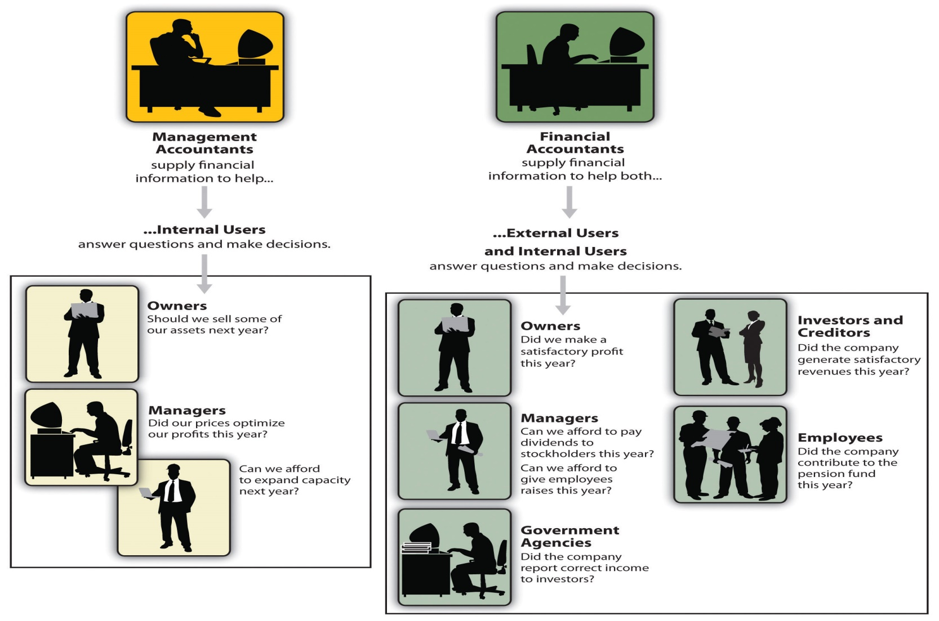

Figure1.0: Management and Financial Accounting

|  |  |  |
| --- | --- | --- |
| **Aspects** | **Accounts Payable** | **Accounts Receivable** |
| Refers to | Money that the company owes to others | Money that others owe to the company |
| Abbreviation | AP or A/P | AR or A/R |
| Paid to whom? | Accounts payable are amounts a company owes because it purchased goods or services on credit from a supplier or vendor. | Accounts receivable are amounts a company has a right to collect because it sold goods or services on credit to a customer. |
| Recorded as | Liability (payable always a liability) | Asset (receivable always an asset) |
| How each affects a business | Accounts payable will decrease a company's cash | Accounts receivable will increase a company's cash |
| What causes this Transaction | Purchasing goods on credit | Selling goods on credit |

Figure 1.1: Difference between accounts payable and accounts receivable

THE END